Table Fan
Version 1.0

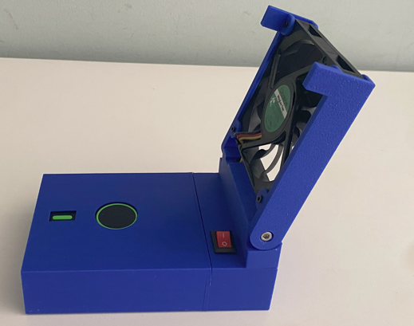

Project Goals
I have some PC fans from an old project and I decide to wire it with a USB Power Bank to create a portable fan.
Mainly to remove toxic fumes while using the soldering iron, but also as a portable fan for the summer.
And in the same time it could also be a power bank, why not?
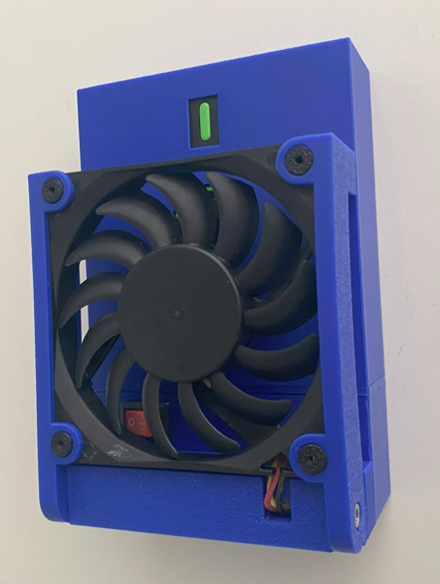

Use Cases
- Summer heat relief
- Soldering Iron Fumes dispersion
- Power bank

Components

Power bank
This is the power bank I have incorporated in the project.
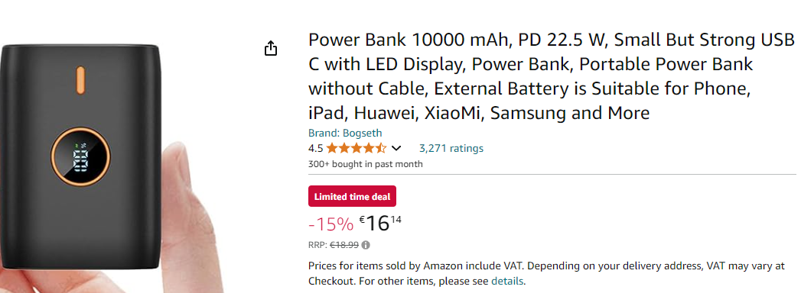
Amazon Germany: https://amzn.eu/d/j4mhf3Z
Amazon Italy: https://amzn.eu/d/agR1Bto
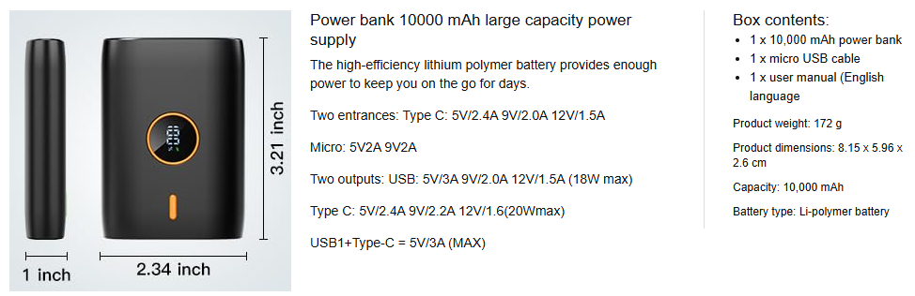

Why I choose it:
- Because it has a capacity of 10Ah
- Because it has a USB A on one side and USB-C / Micro USB for charging in the opposite side. This make possible the connection with the USB decoy circuit on one side and leaves the charging connectors available on the other side.
- It can generate 12VD output.

PC Fan
Size: 70 x 70 mm
Mounting: 60 x 60
Voltage: 12 VDC
Power: 0.7 W

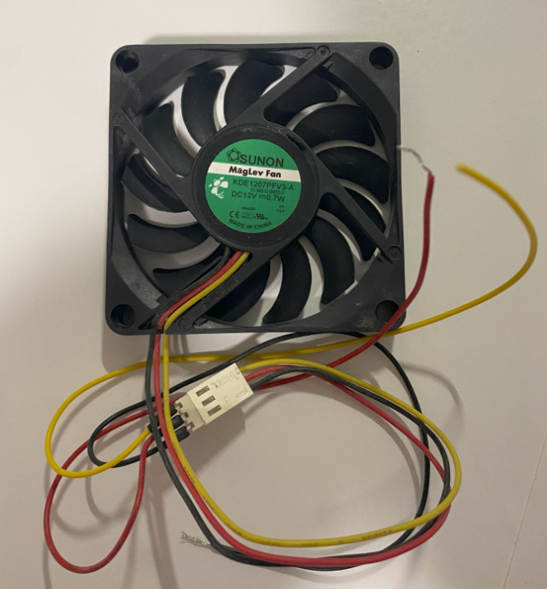

Electronic board – USB Decoy
This board is used to trigger the power bank to generate a 12 Vdc VBUS.
This should make the system more efficient since there is just one power converter, in the power bank.
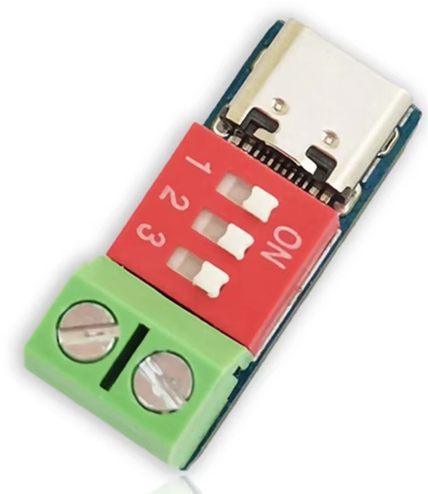 | 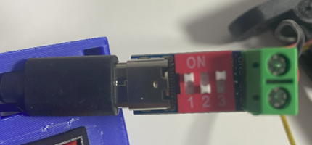

Mechanical parts

Battery Holder
Width: 77 mm
this has to align to the base jont size.
67 mm + 5 mm + 5 mm
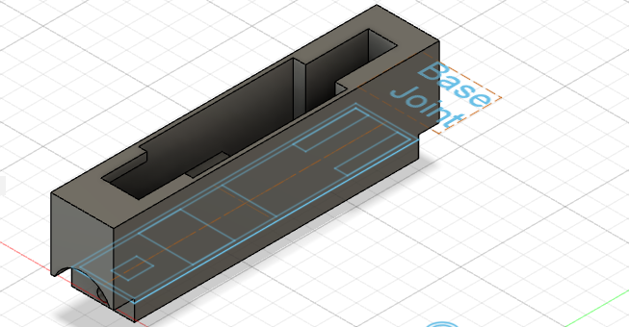

Wall Thikness: 1 mm for all sides
In past realization I use 2 mm for the side, but it is not neccessary
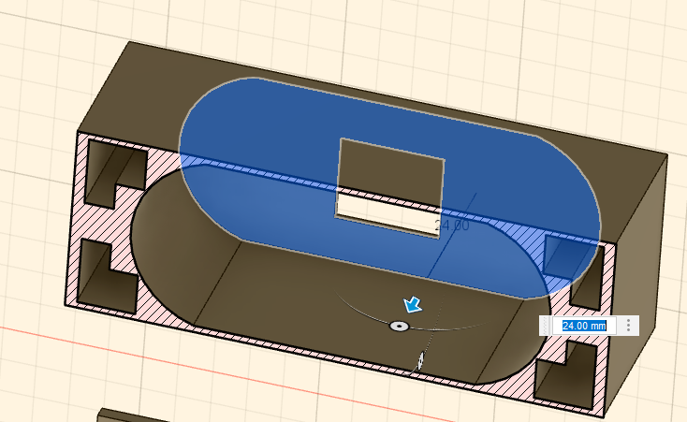

Back Window: width 11 height 13, 4,5 mm offset on the micro USB connector side.
This is used to charge / discarge the battery using USB-C or Micro USB connector
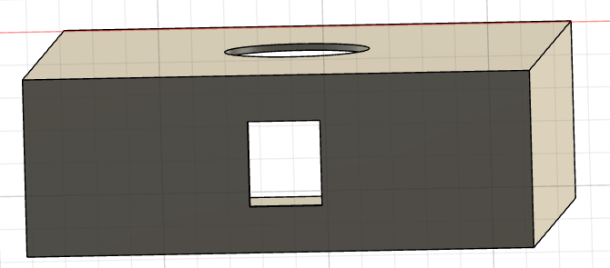

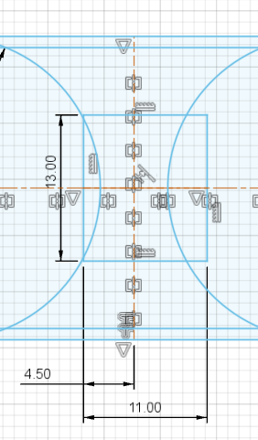

Battery housing: 2 x 27 mm circles, spaced by 33 mm, with a cut at 25 mm on top and bottom side.
The exact shape is difficult to guess, but this is a good approximation and it keeps the battery locked.
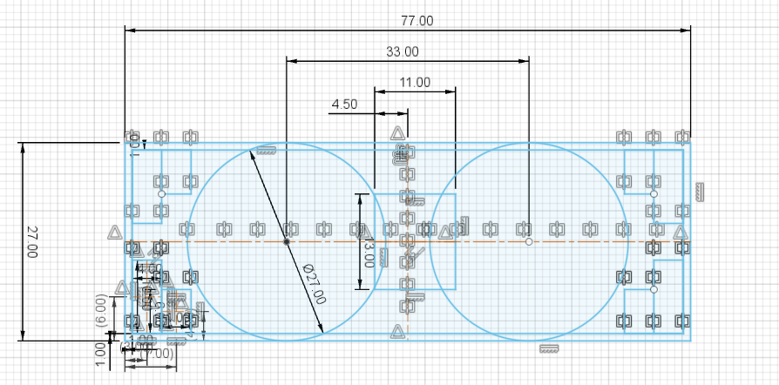

Cover Anchor: I use 4 L shaped slots that has also the fuction of saving material.
This slot generate a T shaped beam on the side of the battery holder, that make it stiff and resistent.
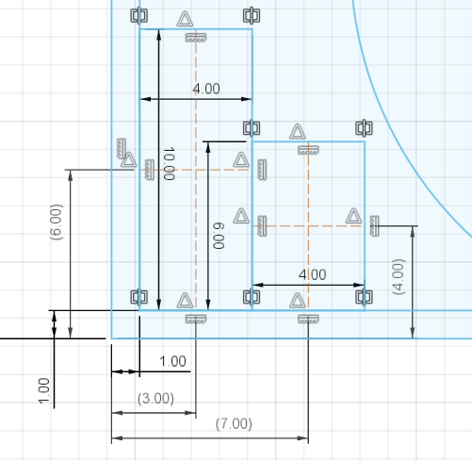

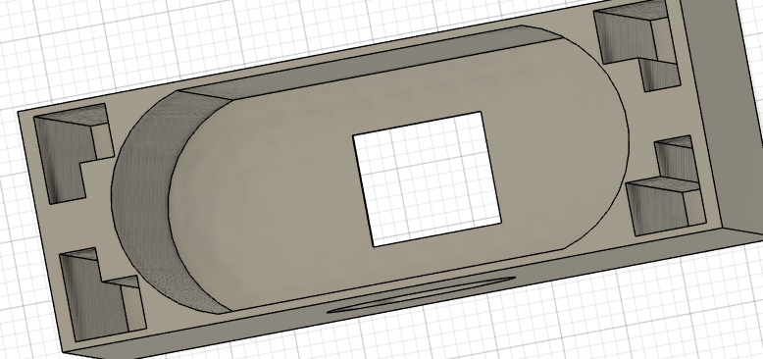

State of charge Indicator: On the top side the SOC indicator is visible
The indicator is aligned to the vertical axis and it is 41.25 mm away from the top side
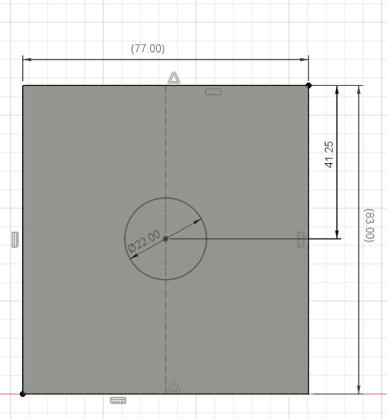

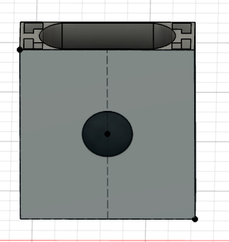

Battery cover
This is a 2 mm thickness layer that cover the battery and hold it in place.
4 Stub with an extrusion height of 10 mm are used to hook the cover to the battery holder
4 slot are used to allow the hooks of the Electronic Section to pass through.
The 15 x 20 mm slot in the center is used by the USB A connector that power the fan
2 Additional 12 x 5 mm slots, in the horizontal symmetry axis are used to facilitate the cover extraction while in place.
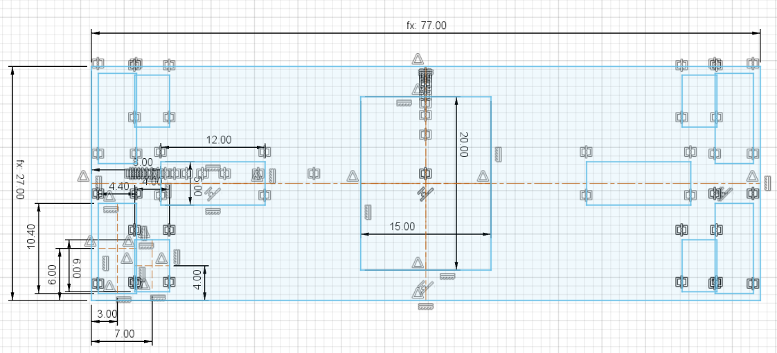

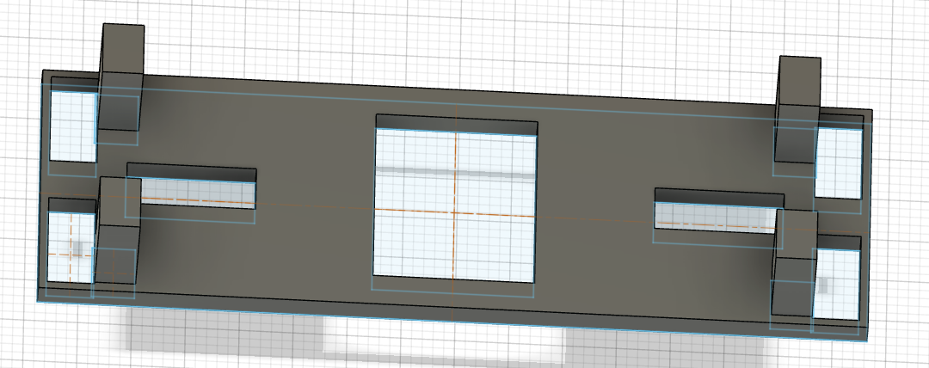

Cover
This is the part of the base where the fan is connected and where there is the switch

More Ideas
Can I create a Table Air Purifier?
https://amzn.eu/d/5t24OPc
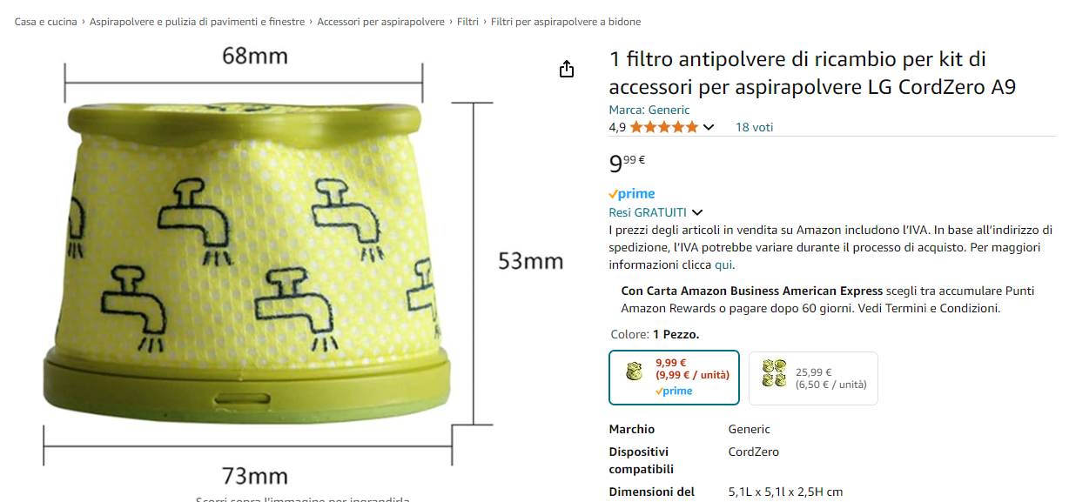

For next Iteration
Use 4 wires fan, so we can use PWM to control speed
Improve the locking between the battery cover and the battery holder

